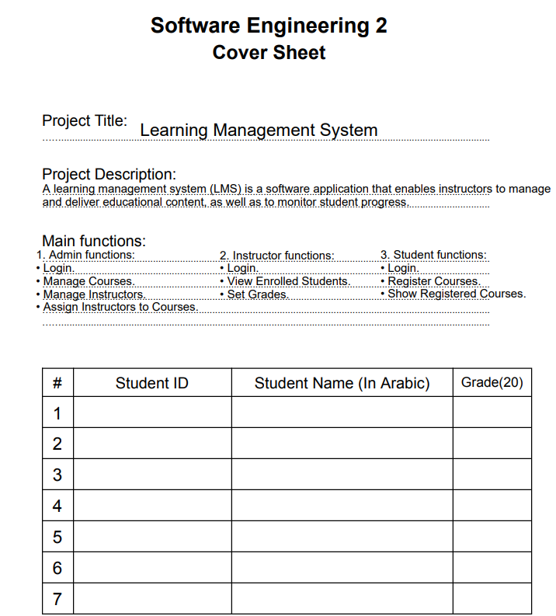

**UML Diagrams**

1. A picture containing diagram, line, pattern

   Description automatically generated **Use Case Diagram:**
2. **A picture containing diagram, text, plan, technical drawing

   Description automatically generated Class Diagram:**

**OCL Constraints:**

1. **Activity Diagram:**
2. **Login**

1. **Add Course**

1. **View Enrolled Students**

1. **Manage Instructor**

1. A diagram of course

   Description automatically generated with low confidence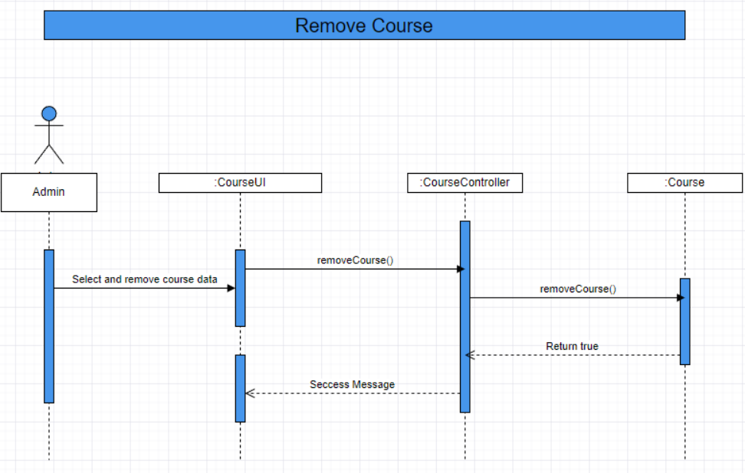 **Sequence Diagram:**

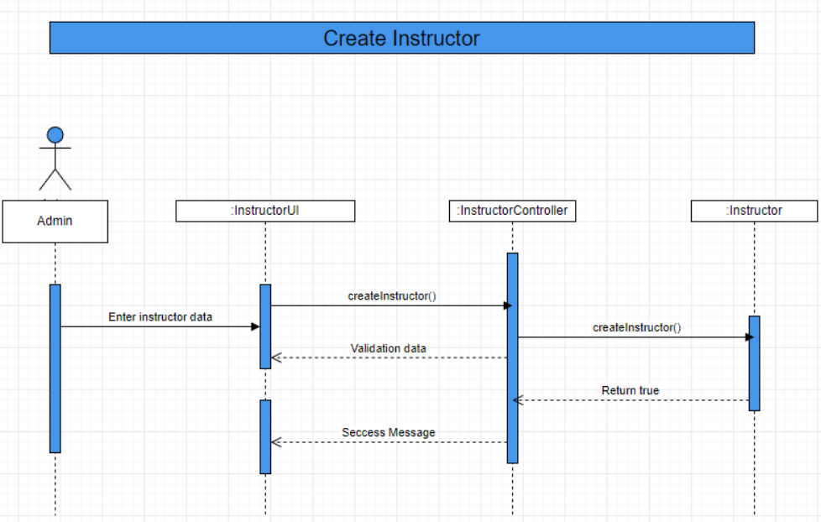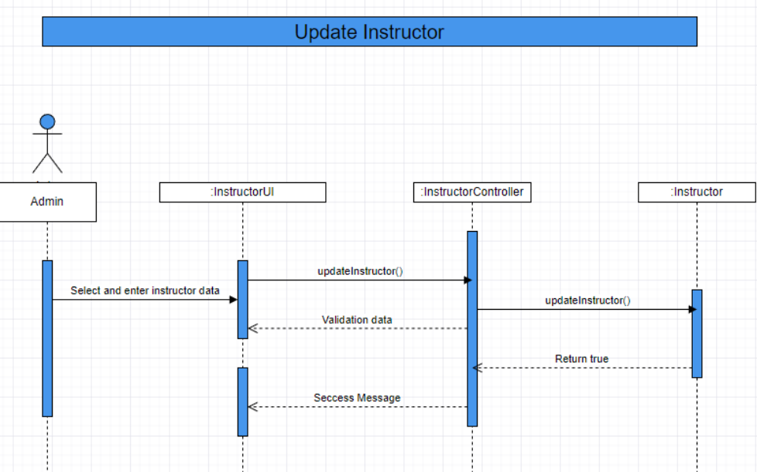

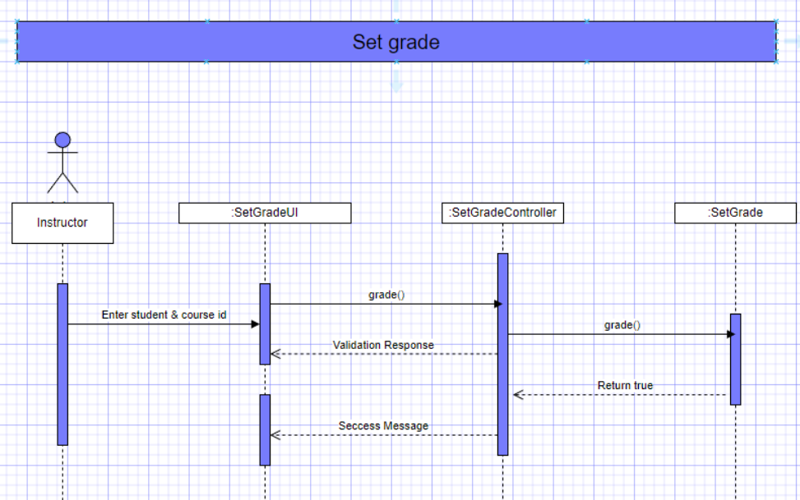

1. **Communication Diagram:**
2. **Admin Communication Diagram**

1. **Instructor Communication Diagram**

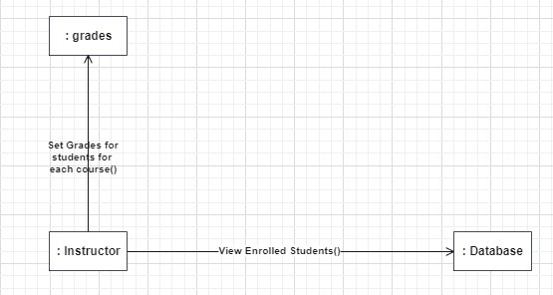

1. **Student Communication Diagram**

1. **State Diagram:**
2. A picture containing diagram, text, plan, technical drawing

   Description automatically generated**Admin State Diagram**
3. A picture containing diagram, text, plan, technical drawing

   Description automatically generated**Instructor State Diagram**
4. A picture containing text, diagram, plan, line

   Description automatically generated**Student State Diagram**
5. **A picture containing diagram, drawing, sketch, line

   Description automatically generated ERD:**

**GitHub Link**

<https://github.com/Karim-Sameh/SW2_Project>